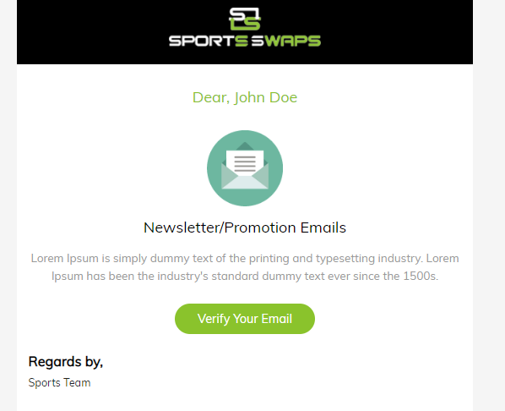

Delete verify your email.

Best Regards,

SportsSwaps